Networks Exercises – Line Encoding

# Exercise 2

**Manchester and Differential Manchester Encoding**

In both these encoding schemes there is a transition at the centre of the bit interval. This is used to provide synchronisation. In the case of Manchester encoding the transition at the centre of the bit interval also signals the value of the bit. A low to high transition signals a one and a high to low transition signals a zero. In differential Manchester encoding it is whether or not there is a transition at the beginning of the bit interval that signals the value of the bit. No transition signifies a one and a transition signifies a zero. ←Direction of propagation

1 0 1 0

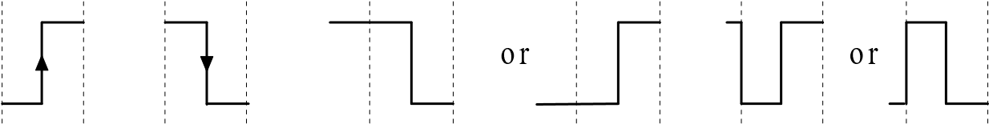

Manchester encoding Differential Manchester encoding

# NOTE: In all of the following examples and questions



**the MSB is on the left and transmitted first.**

1. Encode the bit stream, **01100010**, using Manchester and differential Manchester encoding.



Manchester Encoding



MSB bit 7 bit 6 bit 5 bit 4 bit 3 bit 2 bit 1

←Direction of propagation

Differential Manchester Encoding



MSB bit 7 bit 6 bit 5 bit 4 bit 3 bit 2 bit 1

←Direction of propagation

**Assume the bit preceding the MSB is low at the bit boundary**.

2

. Decode the following Manchester encoded bit stream.

←

Direction of propagation

Decoded bit steam = 100010

1

3. Decode the following differential Manchester encoded bit stream.

←Direction of propagation

Decoded bit stream =1000110

**Note: the bit preceding the MSB is high at the bit boundary**.

There are many different line encodings. The next section gives the line encoding rules for AMI.

AMI forms the basis for HDB3 and CMI. HDB3 and CMI are ITU-T standard line encoding schemes used in the synchronous digital hierarchy (SDH).

**Bipolar Alternate Mark Inversion (AMI)**

In this scheme 0 is represented by zero line voltage and 1 by a positive or negative alternate pulse. It thus uses three signalling levels. The successive binary 1 pulses alternate in polarity. This provides good synchronisation provided lots of 1 are to be encoded. There is no dc offset or baseline wander. Loss of synchronisation can result when long strings of binary 0s are sent.

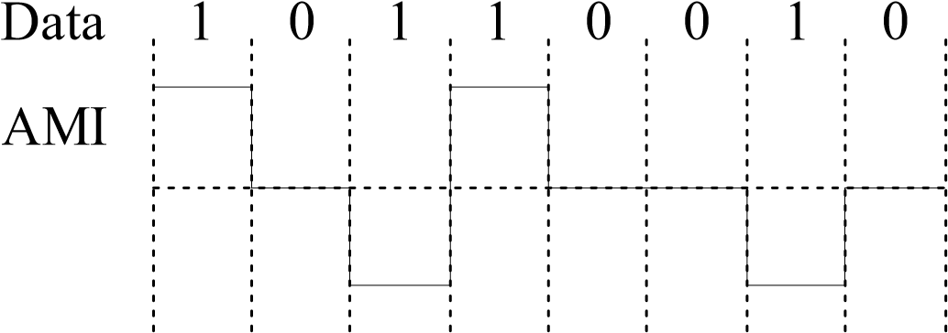

←Direction of propagation 4. Encode the bit stream **01100010** using AMI.

MSB bit 7 bit 6 bit 5 bit 4 bit 3 bit 2 bit 1

←Direction of propagation

5. Decode the following AMI encoded bit stream.



←Direction of propagation

Decoded bit steam =